**Creating Database**

1. Open SLQ Shell

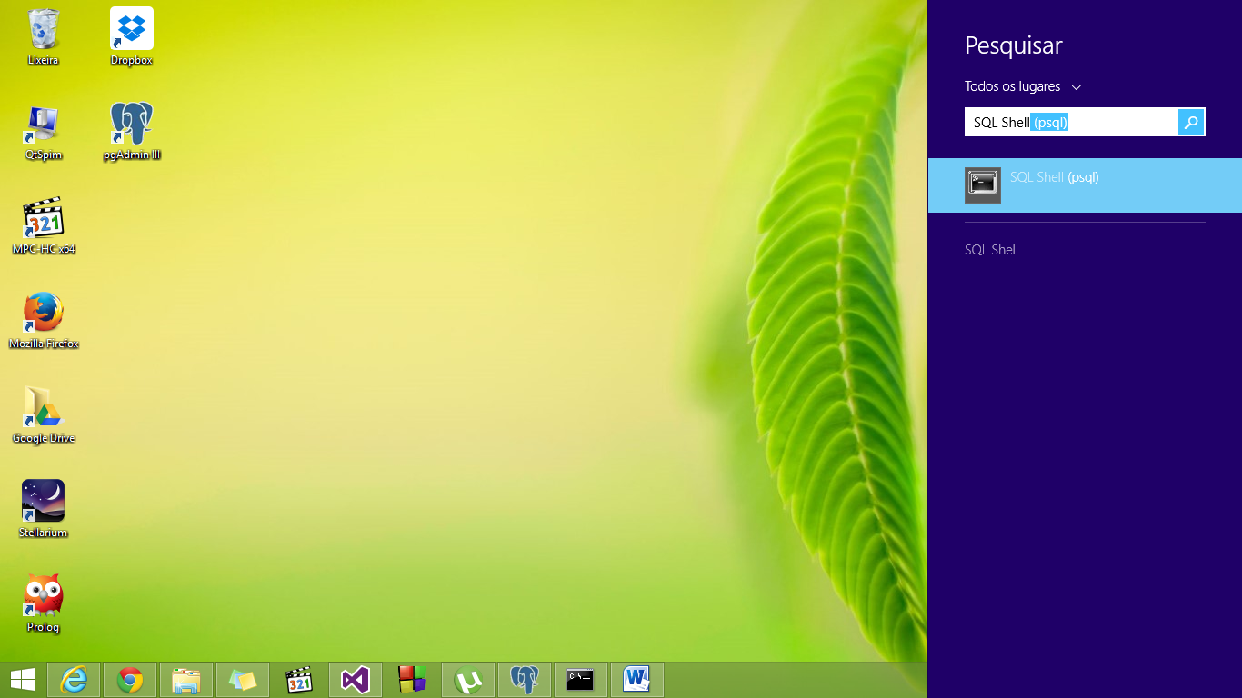

1. Press enter until appear “Postgres user password:”  
   (In my computer “Senha para usuário postgress because is in Portuguese)

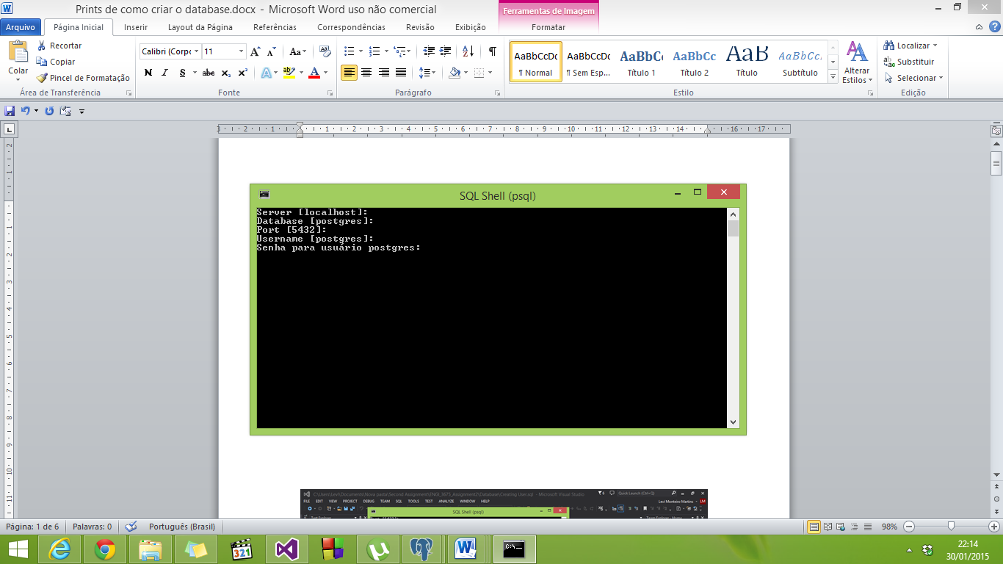

1. 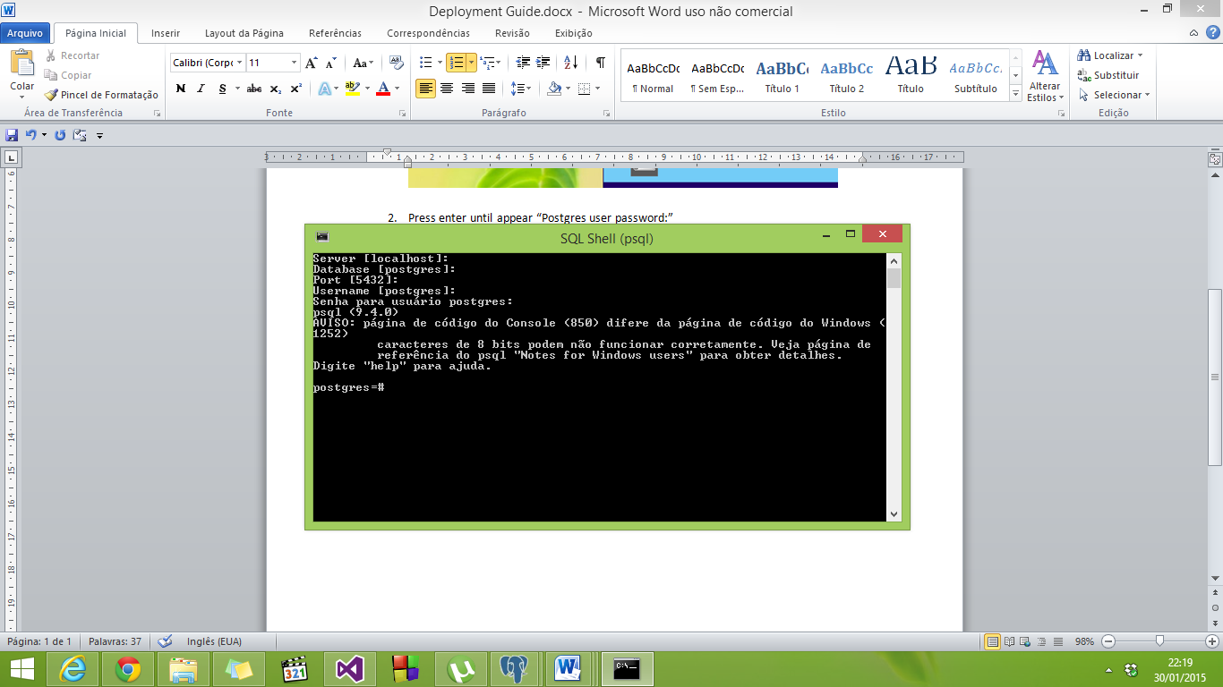Your password will be invisible. After typed your password, press “Enter”.

1. Go to Visual Studio
2. Go to Source Control Explorer
3. Open Database

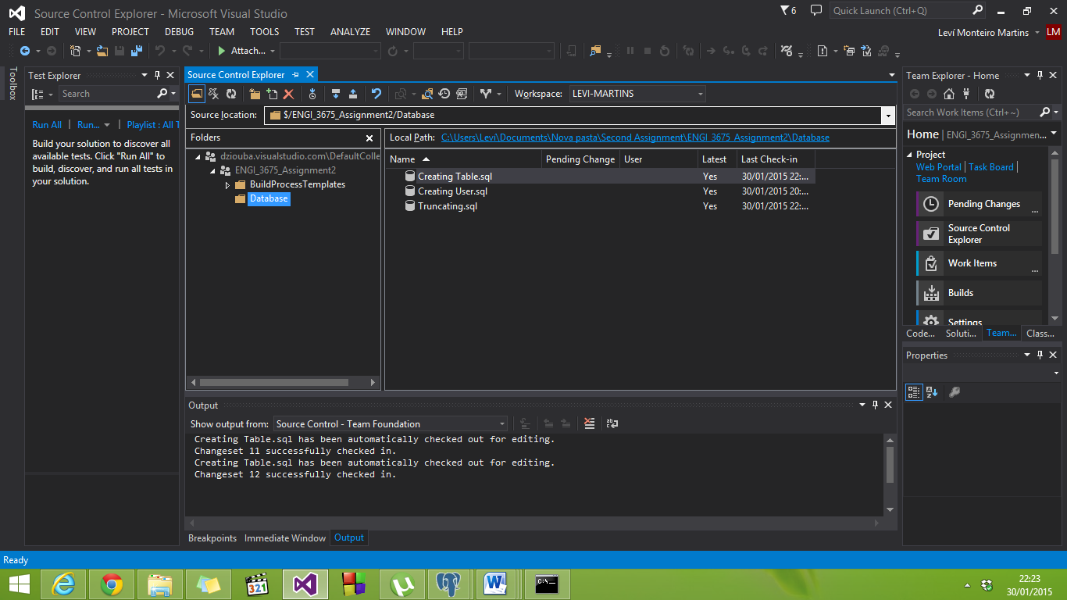

1. Open ***Creating User.sql*** that is the code to create the Database and the users. You should change the name of the user Levi to your name.
2. Copy this code and paste to SQL Shell, then press Enter.
3. In your screen should appear as the follow:

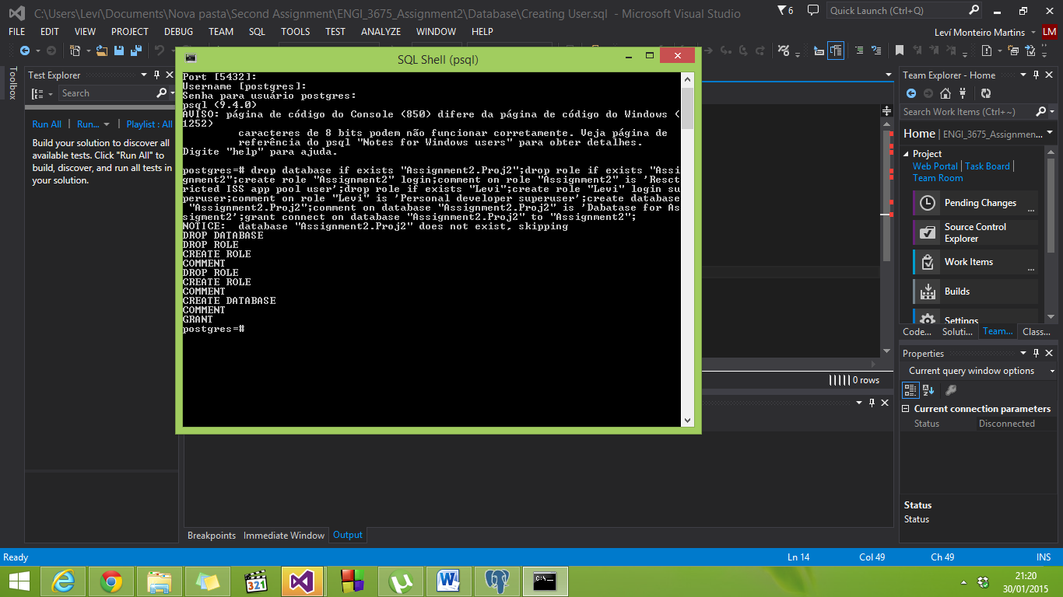

**THE DATABASE AND USERS WERE CREATED**

1. Open **pgAdmin III.** The database created should appear inside Databases:

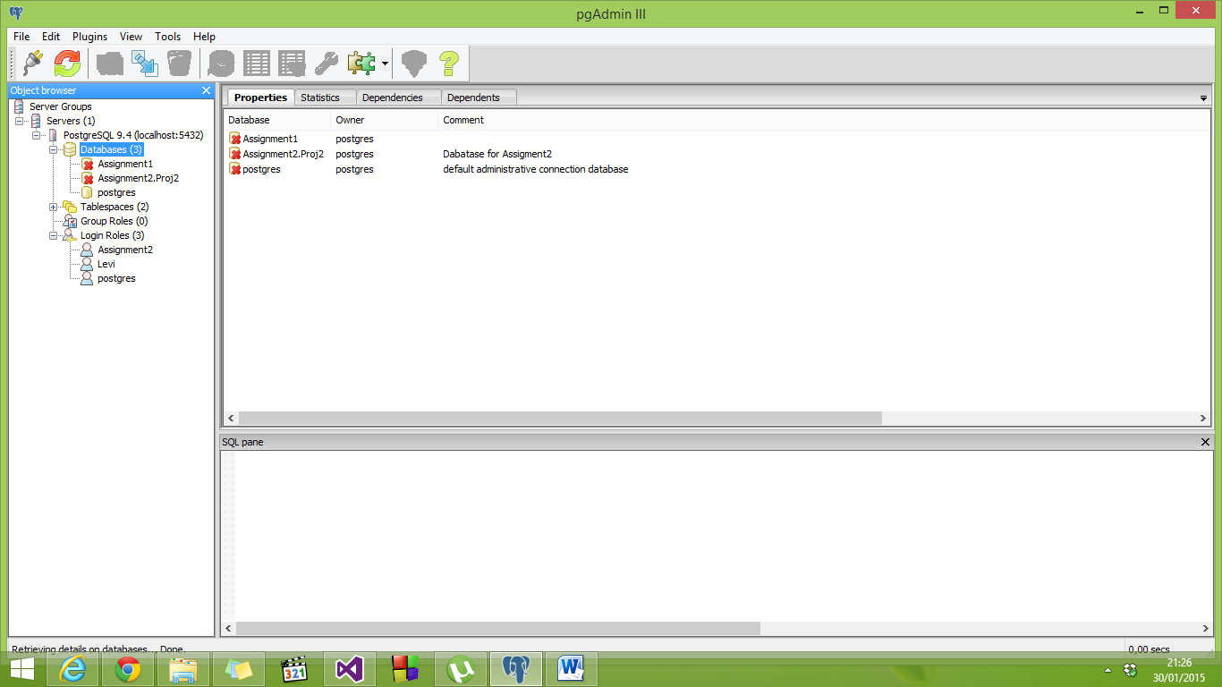

If doesn’t appear Assignment2.Proj2 inside Databases, you should refresh Databases:

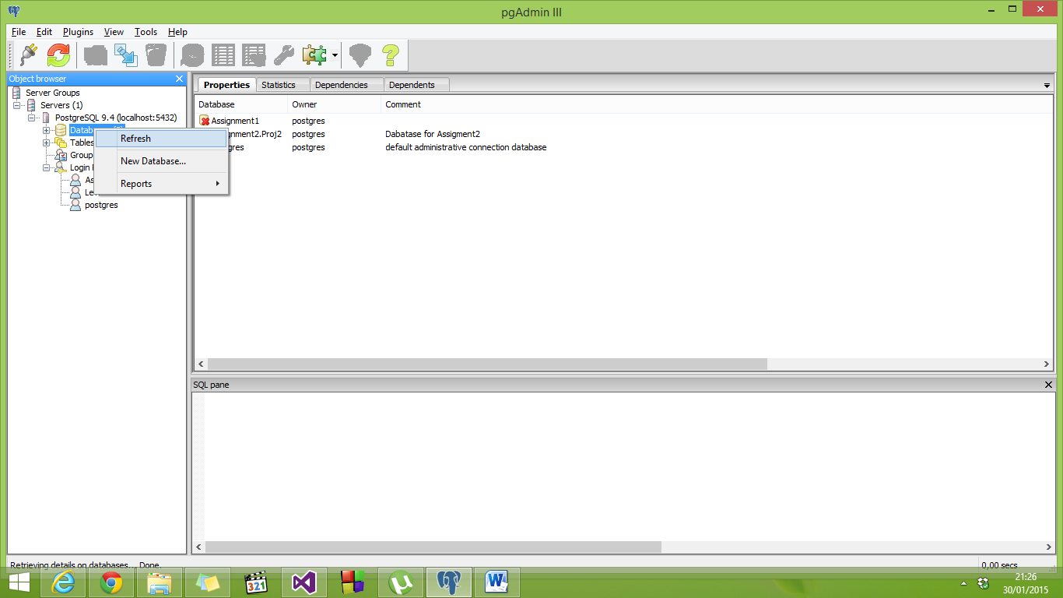

1. Check **Login Roles** to see if your users were created (Assignment 2 and Levi), Levi is a superuser.

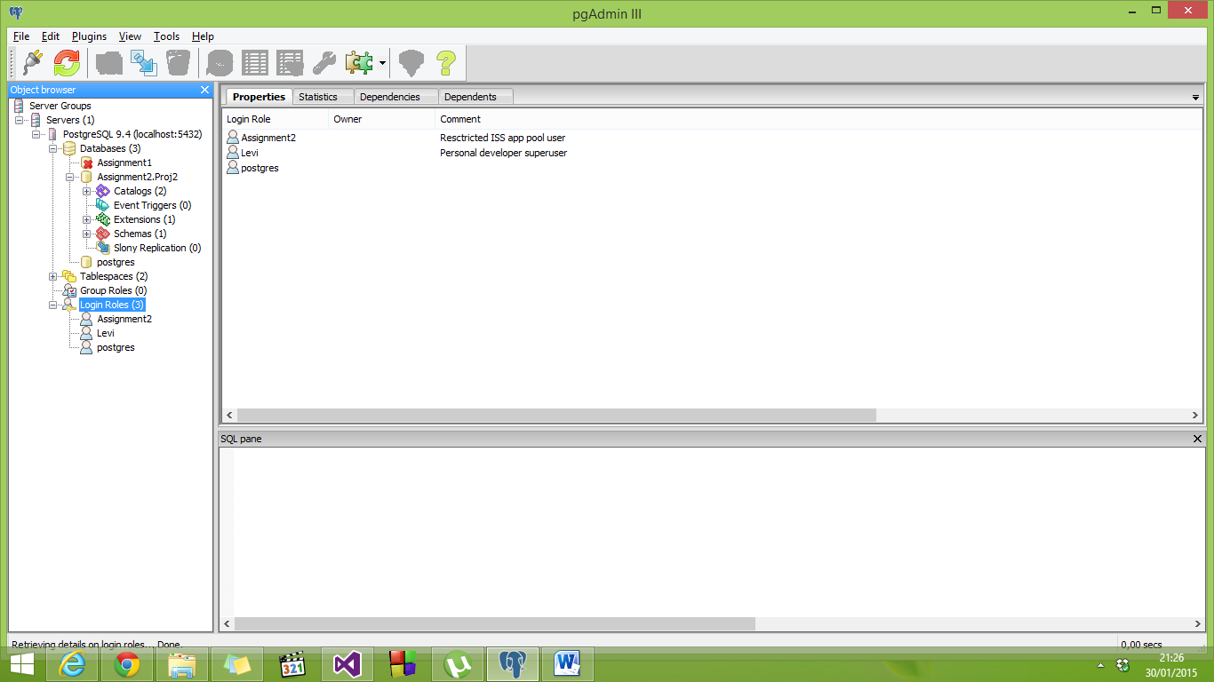

**Creating Tables and Truncating**

1. Connect your new database “Assignment2.Proj2” (just click on it).
2. Click in SQL to open the Query:

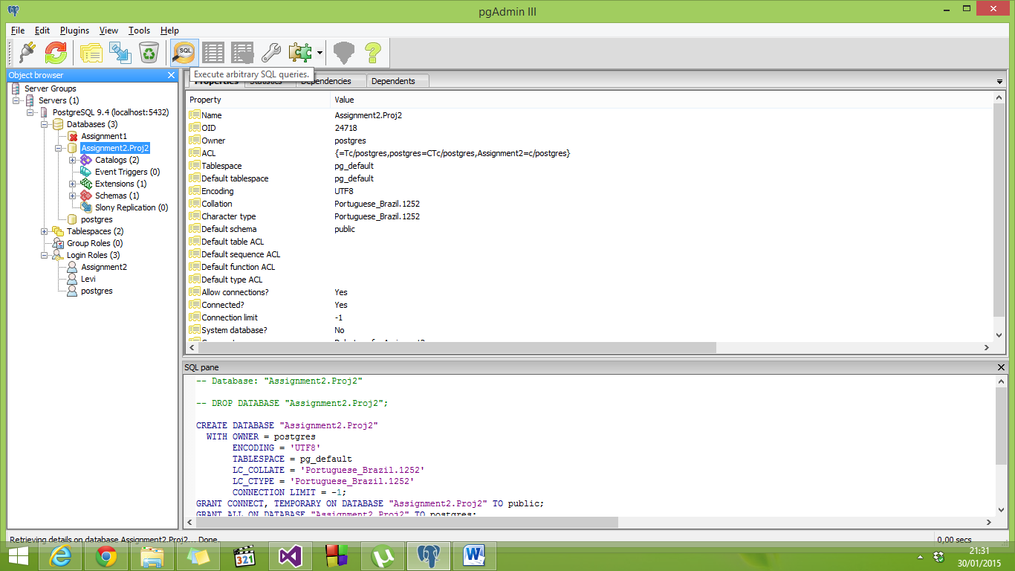

1. 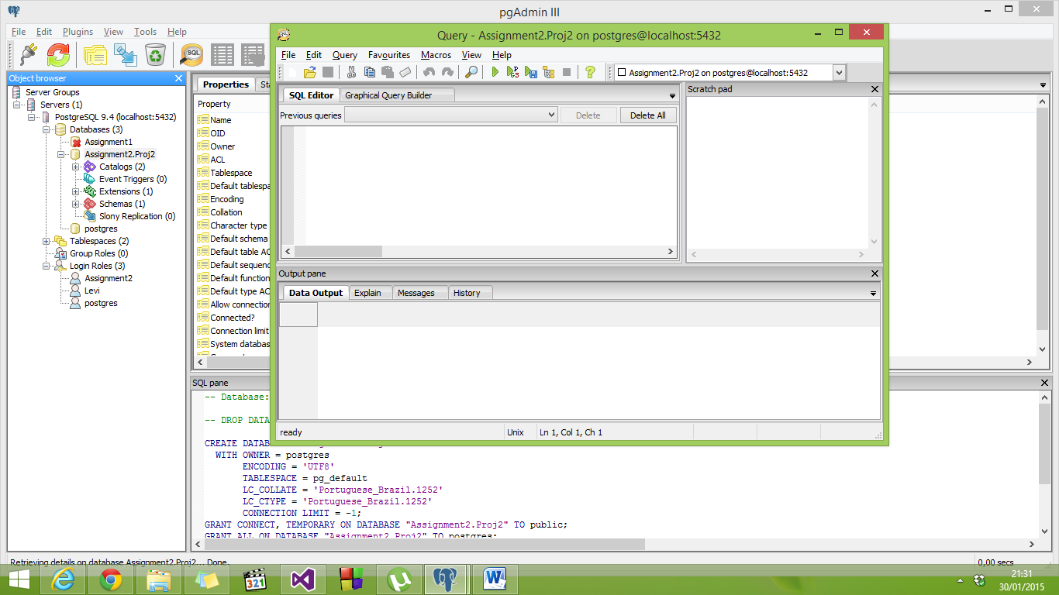Go to Visual Studio in Database file.
2. Open and copy Creating Table.sql code.
3. Add this code in the Sql Editor, then Execute Query:  
   (Close this window)

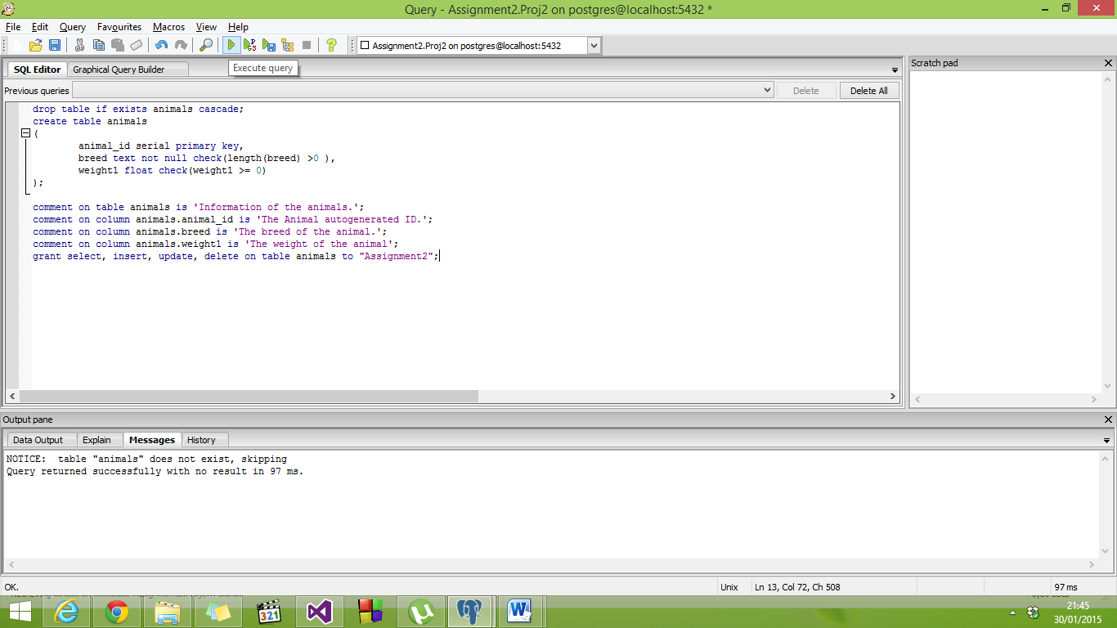

**THE TABLE WAS CREATED**

1. Open a new SQL Query.
2. Inside Database file in Visual Studio Copy the file Truncating.sql. Then paste to the new SQL Query and Execute.

The Truncating.sql file will clean the rows and then will add some values.

GREAT! IT’S DONE

If you want to check everything:

1. Open **pgAdmin.**
2. Connect the **Assignment2.Proj2** database.
3. Open **Schemas,** then open expand **public.**
4. Expand **Tables,** you must see “animals” select it.
5. Click on the top “View data in the selected object”:

